ASU-TDC
TRaining and development center, Ain Shams university
Trainee Handbook for Complementary Tracks and Micro-Credentials

Trainee Handbook for the Financial Technology (FinTech) Complementary Track

1. Introduction
This handbook provides trainees with guidance on the Financial Technology (FinTech) complementary track, including micro-credential’s structure, learning pathways, registration procedures, eligibility requirements, assessment methods, learner support, quality assurance, and certification.
The FinTech track is aligned with the European approach to micro-credentials for lifelong learning and employability. It aims to bridge the gap between academic education and labor market needs by developing practical competencies in digital finance, blockchain, artificial intelligence, digital payments, cybersecurity, and financial innovation.
The program adopts a competency-based, learner-centered approach that combines theoretical knowledge with practical applications in alignment with EQF Level 6 and ECTS standards.

2. Complementary Track MAP
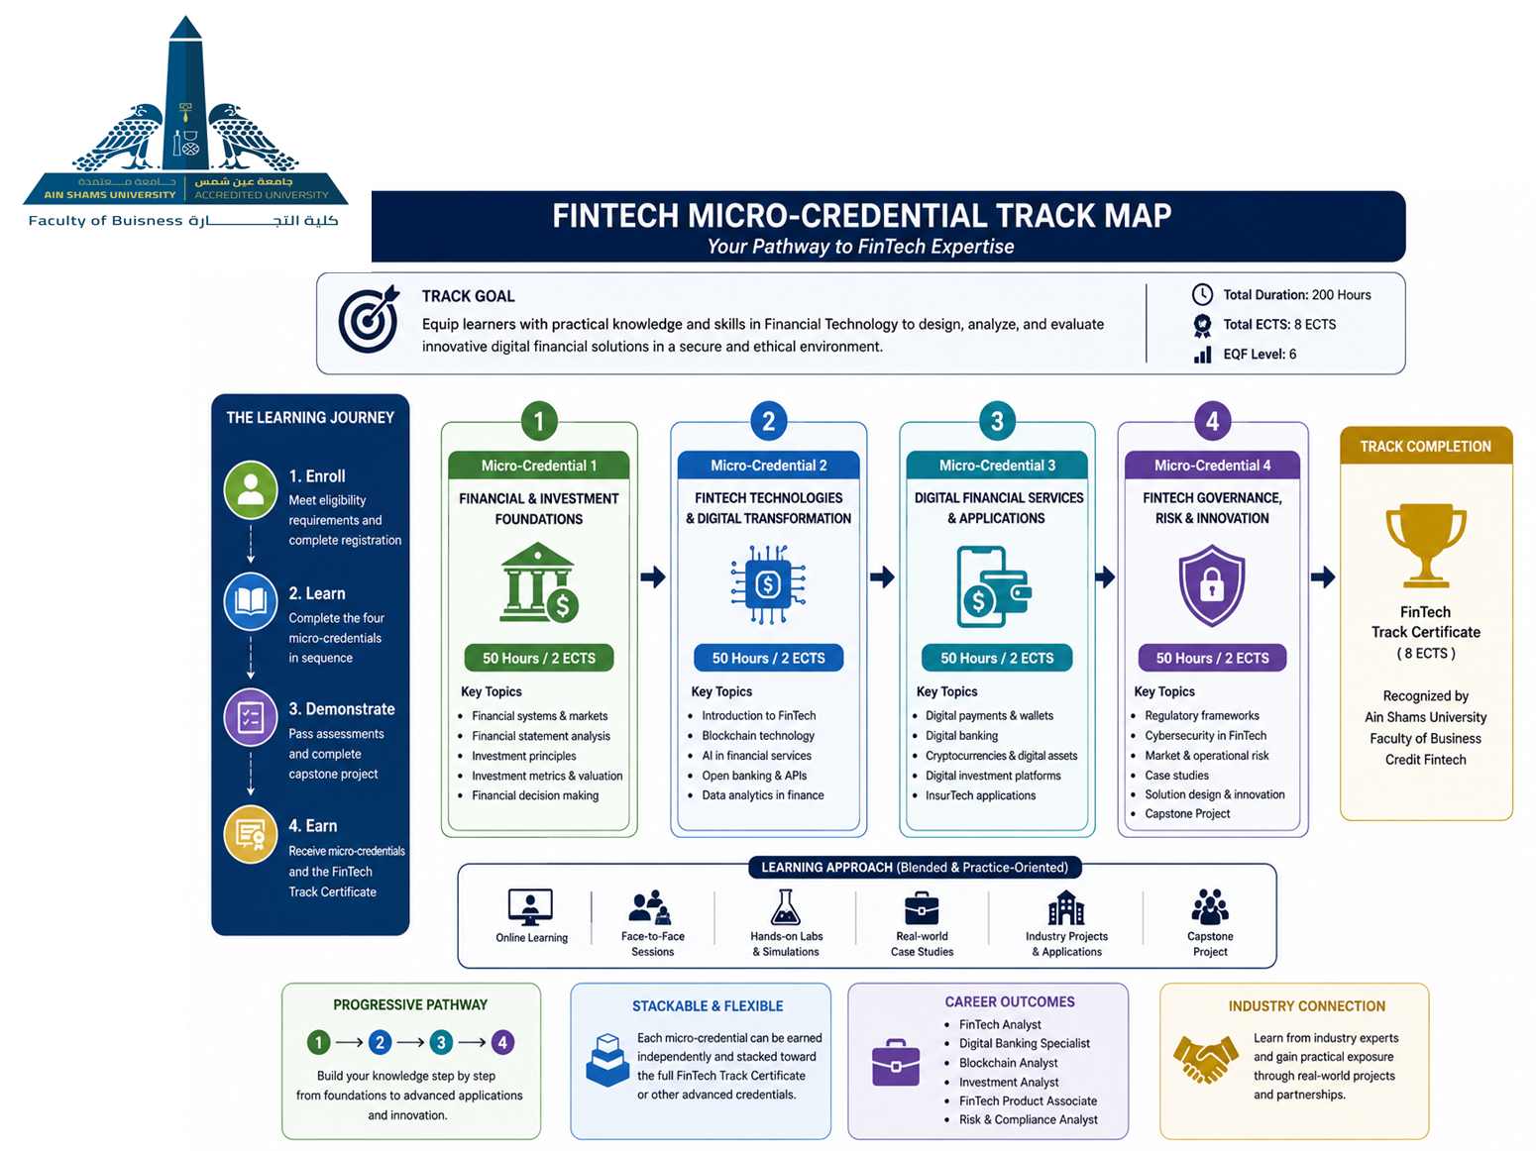

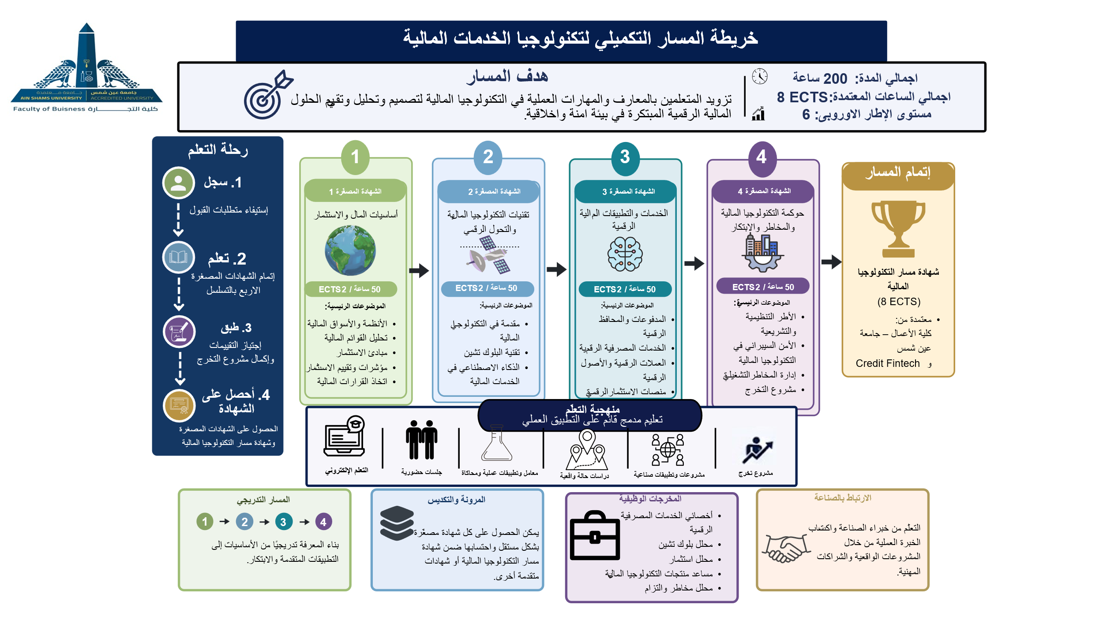

3. Registration Procedures
Applicants must complete the online registration through the official Training and Development Center platform (tdc.asu.edu.eg) and submit all required supporting documents before the announced deadlines.
Required documents include:
- Completed registration form
- National ID or passport copy
- Academic qualification documents
- Proof of English proficiency where applicable
- Approval of prerequisites where required (Appendix 1)
Applicants will receive confirmation of acceptance after academic review and verification of eligibility requirements.

4. Eligibility Criteria
Eligibility requirements may vary according to the learner’s academic and professional background. Applicants should meet the following minimum requirements:
- Minimum educational qualification: Undergraduate student or bachelor’s degree holder in business, economics, commerce, management information systems, computer science, or related disciplines.
- Basic digital literacy skills.
- English language proficiency equivalent to B1 level or above.
- Basic understanding of business and financial concepts is preferred.
- Motivation to pursue learning in financial technology and digital transformation fields

5. Prerequisites
Some micro-credentials may require prior completion of introductory modules or equivalent experience.
Recommended prerequisites include:
- Basic computer and internet usage skills.
- Introductory knowledge of economics or finance.
- Familiarity with digital applications and online learning platforms.

6. Transfer Between Complementary Tracks
Learners may request transfer between complementary tracks based on completed micro-credentials, achieved learning outcomes, and academic equivalency.
Transfer requests are subject to approval by the academic coordinator and according to institutional regulations governing credit transfer and stackability.

7. Complementary Track Overview
Track Name | Target Group | Duration | Total ECTS/Hours | Track Coordinator
Financial Technology (FinTech) | Students, graduates, banking professionals, financial analysts, and professionals interested in digital finance | 200 Learning Hours | 8 ECTS / 200 Hours | Faculty of Business – Ain Shams University

8. Learning Settings and Delivery Modes
The complementary track follows a practice-oriented approach where practical learning constitutes approximately 60% of the learning activities, while theoretical learning constitutes approximately 40%.
Learning settings include:
- Online learning
- Physical face-to-face learning
- Blended learning
- Laboratory-based training
- Industry-based practical applications
- Case studies and simulations
- Group projects and workshops
- Capstone project development

9. Micro-Credentials Included in the Track
Micro-Credential Title | Learning Outcomes | ECTS/Hours | Assessment Method | Delivery Mode | EQF Level | Responsible Trainer
Foundations of Finance and Investment | Analyze financial statements, interpret investment indicators, compare investment strategies, and apply financial decision-making principles. | 2 ECTS / 50 Hours | Quizzes, practical exercises, case studies | Blended | EQF Level 6 | Finance Specialist
FinTech Technologies and Digital Transformation | Explain FinTech ecosystems, evaluate blockchain applications, analyze AI use in finance, and assess digital transformation trends. | 2 ECTS / 50 Hours | Assignments, presentations, practical labs | Blended | EQF Level 6 | FinTech Specialist
Digital Financial Services and Applications | Apply digital payment systems, evaluate e-wallets and digital banking models, and analyze cryptocurrency and digital asset applications. | 2 ECTS / 50 Hours | Simulations, practical projects, case analysis | Blended | EQF Level 6 | Digital Banking Expert
FinTech Governance, Cybersecurity, and Innovation | Evaluate cybersecurity risks, analyze regulatory frameworks, design basic FinTech solutions, and develop innovative financial technology proposals. | 2 ECTS / 50 Hours | Capstone project, practical assessment, final presentation | Blended | EQF Level 6 | Cybersecurity & Innovation Expert

10. Standard Elements for Each Micro-Credential (Annex I)
Title of the Micro-Credential | Foundations of Finance and Investment
The Learner Identification | • Undergraduate students in Faculties of Business, Commerce, Economics, or related disciplines.• Graduates seeking employment in banking, investment, and financial technology sectors.• Professionals working in financial institutions aiming to enhance digital finance competencies.• Entrepreneurs and individuals interested in financial literacy and investment technologies.
Issuing Institution | Ain Shams University
Date of Issuing
Academic Workload | The micro-credential requires a total notional workload of 50 hours, equivalent to 2 ECTS credits. This workload includes contact hours, guided practice, financial analysis exercises, independent learning activities, case-study discussions, simulations, and assessment tasks required to achieve the intended learning outcomes.
Participation Mode | Trainees participate in financial analysis exercises, investment simulations, case-study discussions, guided workshops, collaborative problem-solving tasks, digital finance activities, and practical applications related to financial markets and investment decision-making.
Quality Assurance Process | The micro-credential is underpinned by an outcomes-based and competency-based quality assurance approach. Quality is ensured through clearly defined intended learning outcomes, transparent assessment criteria, practical financial analysis tasks, case studies, simulations, portfolio evidence, trainer feedback, peer review, and learner self-reflection. The quality assurance process also includes internal academic review, stakeholder feedback, industry consultation, and continuous improvement mechanisms to ensure alignment with labor-market needs and developments in financial services and investment sectors.

Title of the Micro-Credential | FinTech Technologies and Digital Transformation
The Learner Identification | • Undergraduate students in business and technology-related disciplines.• Graduates interested in financial technology and digital transformation fields.• Banking and financial services professionals seeking FinTech competencies.• Individuals interested in blockchain, AI applications, and digital financial systems.
Issuing Institution | Ain Shams University
Date of Issuing
Academic Workload | The micro-credential requires a total notional workload of 50 hours, equivalent to 2 ECTS credits. This workload includes lectures, guided practice, digital tool exploration, simulations, workshops, case studies, collaborative activities, and assessment tasks required to achieve the intended learning outcomes.
Participation Mode | Trainees participate in blockchain demonstrations, AI application workshops, FinTech platform exploration, digital transformation simulations, collaborative discussions, practical labs, and case-based learning activities related to financial technologies.
Quality Assurance Process | The micro-credential is underpinned by an outcomes-based and competency-based quality assurance approach. Quality is ensured through measurable learning outcomes, practical technology-based tasks, simulations, project activities, trainer feedback, peer evaluation, learner reflection, and transparent assessment methods. Continuous review and stakeholder feedback mechanisms are implemented to maintain alignment with technological developments and labor-market requirements in FinTech and digital transformation sectors.

Title of the Micro-Credential | Digital Financial Services and Applications
The Learner Identification | • Undergraduate students and graduates interested in digital banking and financial services. • Professionals working in banking, payment systems, and financial services sectors.• Learners seeking practical competencies in digital financial applications and platforms.
Issuing Institution | Ain Shams University
Date of Issuing
Academic Workload | The micro-credential requires a total notional workload of 50 hours, equivalent to 2 ECTS credits. This workload includes practical training, simulations, guided exercises, case studies, collaborative activities, independent preparation, and assessment tasks required to achieve the intended learning outcomes.
Participation Mode | Trainees participate in digital payment simulations, e-wallet activities, online banking case studies, cryptocurrency analysis exercises, practical workshops, collaborative discussions, and applied digital finance activities.
Quality Assurance Process | The micro-credential follows an outcomes-based quality assurance approach supported by practical assessment methods and competency-oriented learning activities. Quality is ensured through practical simulations, project-based activities, trainer feedback, transparent rubrics, learner reflection, peer review, and continuous monitoring processes aligned with developments in digital banking and financial technology sectors.

Title of the Micro-Credential | FinTech Governance, Cybersecurity, and Innovation
The Learner Identification | • Undergraduate students and graduates interested in financial governance and innovation.• Professionals working in banking, compliance, cybersecurity, and financial services sectors.• Learners aiming to develop competencies in FinTech regulation, cybersecurity, and innovation management.
Issuing Institution | Ain Shams University
Date of Issuing
Academic Workload | The micro-credential requires a total notional workload of 50 hours, equivalent to 2 ECTS credits. This workload includes guided workshops, cybersecurity simulations, governance case studies, innovation activities, collaborative projects, independent preparation, and assessment tasks required to achieve the intended learning outcomes.
Participation Mode | Trainees participate in cybersecurity simulations, regulatory case analysis, risk-management exercises, innovation workshops, collaborative discussions, practical project development, and capstone project presentations related to FinTech governance and innovation.
Quality Assurance Process | The micro-credential is underpinned by an outcomes-based and competency-based quality assurance approach. Quality is ensured through practical risk-management tasks, cybersecurity simulations, capstone projects, trainer evaluation, peer feedback, self-reflection, transparent assessment rubrics, and continuous programme review. Internal and external stakeholder feedback mechanisms support continuous improvement and alignment with labor-market developments and emerging trends in FinTech governance and innovation.

11. Learning Pathway and Progression
The complementary track is structured to support progressive acquisition of competencies through interconnected micro-credentials.
Learners begin with foundational financial and investment knowledge before progressing toward advanced digital financial services, technological applications, governance, cybersecurity, and innovation.
Each micro-credential builds upon previously acquired competencies and contributes toward the successful completion of the complementary track.
Learners may complete individual micro-credentials independently or complete the full sequence to obtain the complementary track certificate.

12. Assessment and Certification
Each micro-credential includes an assessment strategy aligned with intended learning outcomes.
Assessment Component | Weight
Practical Activities and Labs | 25%
Case Study Analysis | 20%
Assignments and Quizzes | 15%
Participation and Discussions | 10%
Capstone Project and Presentation | 30%
Assessment methods include:

Successful completion of each micro-credential leads to the issuance of an individual micro-credential certificate. Completion of all required micro-credentials and successful completion of the capstone project leads to the issuance of the complementary track completion certificate.

13. Principles for Design and Issuance (Annex II)

13.1 Transparency
The Financial Technology Complementary Track is designed to ensure transparency through clear documentation of all essential micro-credential information, including learning outcomes, workload, participation modes, assessment methods, certification requirements, and quality assurance arrangements.
Each micro-credential follows a standardized description format to ensure clarity, comparability, and accessibility for learners, trainers, employers, and institutional stakeholders.

13.2 Quality Assurance
The FinTech track follows an outcomes-based and competency-based quality assurance approach aligned with European micro-credential principles and EQF Level 6 standards.
Quality is ensured through:
- Clearly defined learning outcomes
- Transparent assessment criteria
- Practical and performance-based activities
- Trainer and peer feedback
- Internal academic review
- Stakeholder and industry consultation
- Continuous program evaluation and improvement

13.3 Recognition
FinTech micro-credentials support professional and institutional recognition through clear documentation of learning outcomes, workload, assessment methods, achieved competencies, and quality assurance processes.
Recognition may support professional development, employability, training progression, or institutional purposes according to the regulations of the receiving institution or authority.

13.4 Portability
The micro-credentials are designed to be portable by providing verifiable and shareable evidence of learner achievement.
Each credential includes:
- Learner identification
- Credential title
- Learning outcomes
- Workload and ECTS
- EQF level
- Assessment methods
- Date of issue
- Quality assurance reference
Learners may store and share credentials digitally to support mobility and recognition across educational and employment contexts.

13.5 Learner-Centered Design
The FinTech track is designed around learners’ professional and employability needs in digital finance and financial technology sectors.
The program combines theoretical knowledge with practical applications in:
- Digital financial services
- Blockchain technologies
- AI applications in finance
- Cybersecurity
- Financial innovation
Learners contribute to program improvement through feedback surveys, reflection activities, peer review, and evaluation processes.

13.6 Accessibility
The FinTech track supports accessibility through:
- Clear admission procedures
- Flexible entry points
- Blended learning delivery
- Stackable micro-credentials
- Transparent assessment and certification requirements
Learners may enroll in individual micro-credentials according to their professional needs and available time without completing the entire track.
Learning materials and activities are provided through both face-to-face and online learning environments to support equitable participation

13.7 Authenticity
The FinTech track ensures authenticity through verified, evidence-based assessment and certification procedures.
Authenticity is supported through:
- Practical and performance-based assessments
- Simulations and case studies
- Capstone projects
- Trainer-supervised activities
- Portfolio evidence
- Institutional verification procedures
Each micro-credential is traceable and aligned with European micro-credential principles and EQF standards.

13.8 Flexibility
The FinTech track adopts a flexible learning structure that allows learners to:
- Enroll in one or more micro-credentials independently
- Complete credentials progressively over time
- Follow stackable learning pathways
- Participate through blended learning formats
Micro-credentials may be completed individually or accumulated toward the full FinTech complementary track certificate

13.9 Inclusiveness
The FinTech track promotes inclusiveness by supporting diverse learner profiles, including:
- Undergraduate students
- Graduates
- Banking professionals
- Entrepreneurs
- Career-transition learners
The program adopts inclusive instructional approaches, collaborative learning activities, guided practice, and multiple assessment methods to ensure fair participation and equal learning opportunities for all eligible learners

14. Learner Support Services
The program provides:
- Academic mentoring
- Career guidance and employability support
- Technical support for digital platforms
- Accessibility accommodations where applicable
- Feedback and complaints mechanisms
- Industry networking opportunities

15. Quality Assurance and Monitoring
Regular monitoring and evaluation procedures are implemented to ensure the quality, relevance, and continuous improvement of the complementary track and associated micro-credentials. Quality assurance mechanisms include:
- Periodic curriculum review
- Learner satisfaction surveys
- Industry partner feedback
- Instructor evaluation and qualification review
- Alignment with labor market developments
- Annual program performance evaluation
- Continuous updating of learning materials and technologies

16. Micro – Credential Fees:
Program fees are determined according to institutional regulations and may vary depending on delivery mode and industry partnerships

17. Approval and Signatures
Track Coordinator: __________________________
Institution Representative: __________________
Date: ______________________________________

18. References
European Council Recommendation on a European approach to micro-credentials for lifelong learning and employability (2022).

