ASU-TDC
TRaining and development center, Ain Shams university
Trainee Handbook for Complementary Tracks and Micro-Credentials

Trainee Handbook for the Complementary Track

for Math & Science Instruction English

1. Introduction
This handbook provides trainees with essential guidance for participating in the Complementary Track for “English for Math & Science Instruction”. It explains the track structure, included micro-credentials, registration procedures, eligibility criteria, learning pathway, assessment methods, learner support services, quality assurance mechanisms, and certification procedures.
The track is designed as a stackable, practice-oriented learning pathway in which each micro-credential can stand alone as an independent certifiable learning unit, while all micro-credentials together form a coherent professional certificate pathway for English-medium Math and Science instruction. Through this pathway, trainees progressively develop the classroom English, academic explanation, learner-centered pedagogy, assessment communication, digital/AI teaching, lesson planning, and portfolio competencies needed for effective English-medium Mathematics and Science teaching.
This handbook therefore serves as a clear reference to support trainees’ successful progression, assessment, and certification throughout the track.

2. Complementary Track MAP
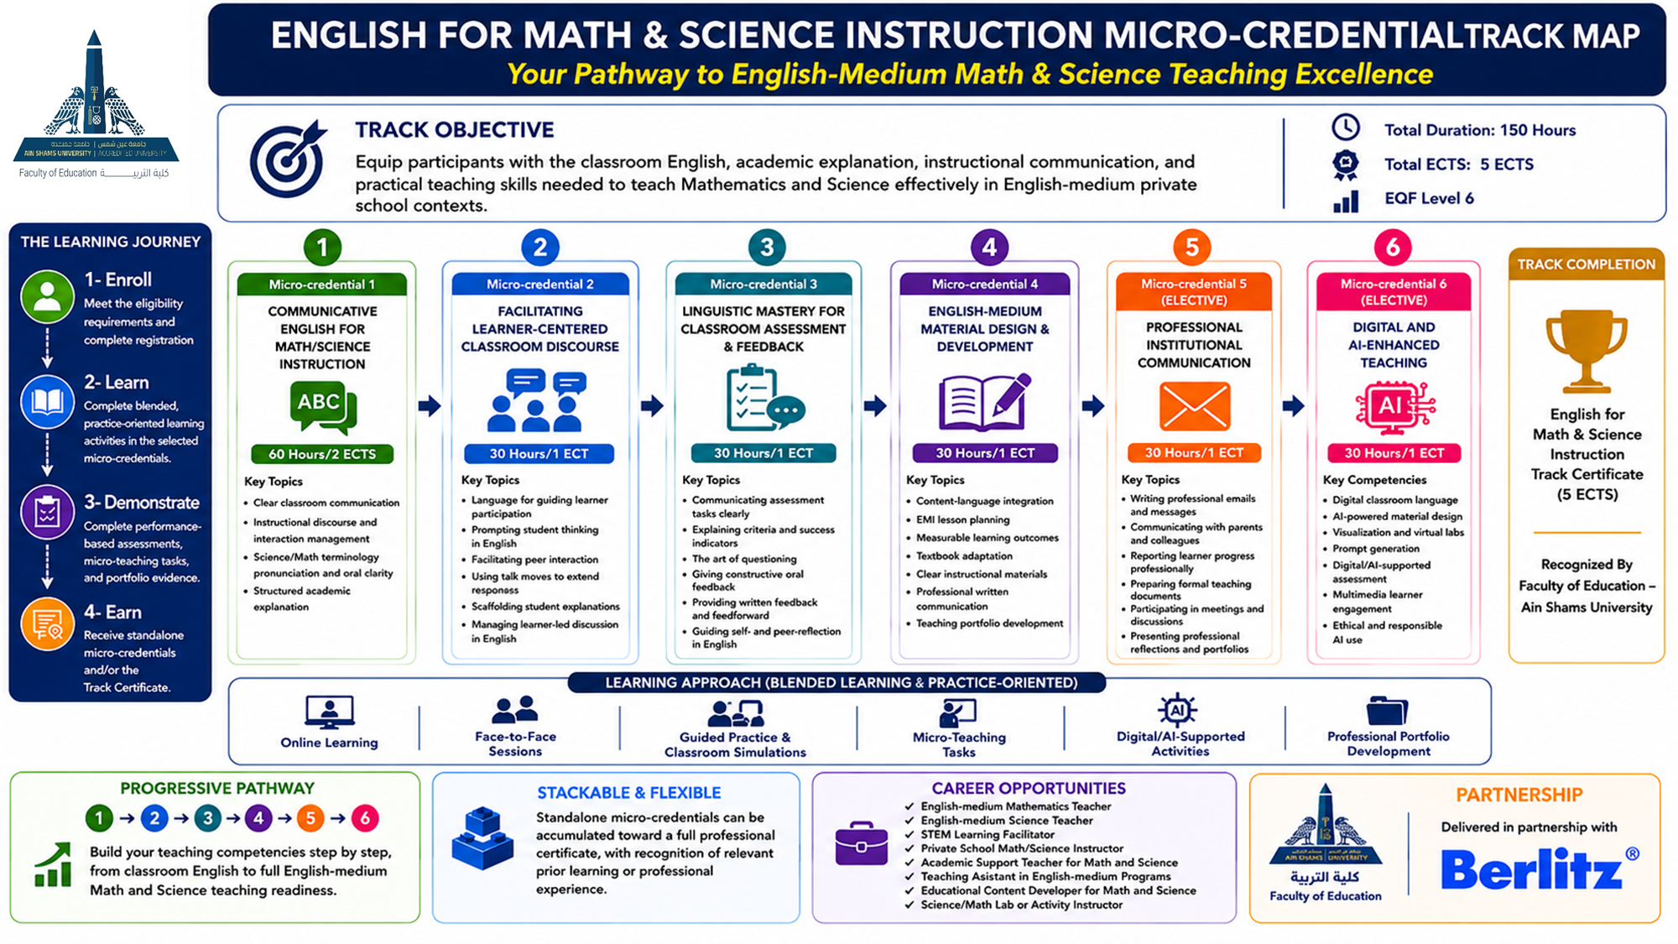

3. Registration Procedures
Applicants seeking to enroll in the English for Math and Science Instruction Track must complete the online registration through tdc.asu.edu.eg before the announced deadline. Applicants are required to submit all supporting documents requested by the Training and Development Center and the Faculty of Education – Ain Shams University.
Required documents include:
- Completed registration form.
- National ID card or passport copy
- Recent personal photo
- Academic qualification certificate or proof of enrollment
- Evidence of relevant academic background
- Proof of English language proficiency, where available
- Brief CV or professional profile
- Proof of teaching/professional experience, where applicable
- Payment receipt, where required
- Any additional documents requested by the TDC or Faculty of Education – Ain Shams University.
Registration is considered complete only after the online application has been submitted, the required documents have been received, and the applicant’s eligibility has been reviewed. Successful applicants will be notified of their enrollment status, selected micro-credential(s), training schedule, and any further administrative or payment procedures, where applicable.

4. Eligibility Criteria

Applicants should meet the following requirements:
- Relevant background in Mathematics, Science, STEM Education, or related fields.
- Teaching, training, classroom, or instructional experience is preferred.
- English proficiency at B1 CEFR or above, preferably B2.
- Basic digital literacy

5. Prerequisites
There are no mandatory prerequisites for enrollment in the micro-credentials. Applicants may register for one or more micro-credentials according to their needs and professional gaps, without following a fixed sequence.

6. Transfer Between Complementary Tracks
To support flexibility and lifelong learning, learners may request transfer between complementary tracks based on completed micro-credentials, achieved ILOs, and equivalency with the target track. Transfer requests are reviewed case by case and may require evidence such as certificates, assessment results, or portfolio work. Final approval is subject to the track coordinator and/or the responsible academic body.

7. Complementary Track Overview
Track Name | Target Group | Duration | Total ECTS/Hours | Track Coordinator
English for Math & Science Instruction | - Pre-service teachers in Faculties of Education.  - Faculty of Education graduates seeking school employment in English -Medium school contexts.  - In-service teachers aiming to develop English-medium teaching skills.  - Academic professionals seeking to enhance instructional delivery in English. | 150 training hours | 5 ECTS | Marwa Mohamed Samir

8. Learning Settings and Delivery Modes
The English for Math and Science Instruction Track adopts a practice-oriented, performance-based approach through blended learning, combining:
- online learning
- face-to-face sessions
- guided practice and classroom simulations,
- micro-teaching tasks,
- digital/AI-supported activities
- professional portfolio development.

.

9. Micro-Credentials Included in the Track
Micro-Credential Title | Learning Outcomes | ECTS/Hours | Assessment Method | Delivery Mode | EQF Level | Responsible Trainer
Communicative English for Math/Science Instruction | - Use clear classroom English to give instructions, set expectations, and guide Math and Science learning activities.  - Ask purposeful questions, check understanding, activate prior knowledge, and clarify meaning.  - Rephrase Math and Science ideas using simpler, accurate, and learner-appropriate English.  - Use subject-specific classroom language to define, explain, compare, sequence, justify, and conclude.  - Pronounce key Math and Science terminology clearly and deliver short oral explanations with appropriate voice control.  - Explain concepts, procedures, processes, relationships, reasoning, evidence, and conclusions logically in English.  - Use examples, analogies, demonstrations, and visual representations to support understanding.  - Interpret charts, graphs, tables, diagrams, and data using appropriate academic English.  - Provide praise, encouragement, immediate feedback, and polite redirection to support participation and classroom interaction.  - Adapt explanations and oral delivery to learners’ language levels while maintaining content accuracy. | 2 ECTS | - Oral Performance Assessment  - Microteaching Assessment  - Observation Checklist  - Peer Review  - Self-Reflective Assessment | Face-to-face learning | 6
Facilitating Learner-Centered Classroom Discourse | - Use English to facilitate learner-centered Math and Science classroom activities.  - Employ interactional language that promotes engagement, participation, and active learning.  - Give clear English instructions for collaborative learning, including roles, routines, and group responsibilities.  - Use talk moves in English to extend learner responses and sustain academic discussion.  - Scaffold students’ use of English to express scientific logic, mathematical reasoning, evidence, and conclusions.  - Use supportive classroom language to build confidence, encourage participation, and maintain a positive learning climate.  - Facilitate inquiry-based and problem-based activities through guiding questions, prompts, and discussion language.  - Manage learner-led activities in English while maintaining structure, accountability, and productive interaction. | 1 ECTS | - Oral Performance Assessment  - Written Performance Assessment  - Microteaching  - Observation  - Portfolio-Based Assessment  - Peer Assessment  - Self-Reflective Assessment | Face-to-face learning | 6
Linguistic Mastery for Classroom Assessment & Feedback | - Use appropriate English for formative and performance-based assessment.  - Write clear assessment items, questions, and task instructions.  - Explain assessment tasks, expectations, criteria, rubrics, and success indicators.  - Use questioning to check understanding, identify misconceptions, and guide reasoning.  - Monitor student progress using supportive assessment language.  - Provide constructive feedback and feedforward on answers, reasoning, and performance.  - Correct errors and redirect students without discouraging participation.  - Facilitate peer feedback and self-reflection respectfully.  - Report learner progress and achievement in professional English.  - Justify assessment decisions using clear evidence-based language. | 1 ECTS | - Oral Performance Assessment  - Written Performance Assessment  - Microteaching  - Observation  - Portfolio-Based Assessment  - Peer Assessment  - Self-Reflective Assessment | Face-to-face learning | 6
English-Medium Material Design & Development | - Integrate content and language objectives in EMI Math and Science lesson planning.  - Identify the main components of effective Math and Science lesson plans.  - Write measurable learning outcomes using appropriate action verbs.  - Design lesson plans aligned with outcomes, activities, assessment, and learner support.  - Adapt textbook content for EMI learners while maintaining subject accuracy.  - Draft clear explanations, handouts, and instructional documents.  - Use professional written English for reports, documentation, and reflections.  - Compile a professional portfolio with lesson plans, materials, documents, and reflective evidence. | 1 ECTS | - Written Performance Assessment  - Portfolio-Based Assessment  - Peer Assessment  - Self-Reflective Assessment | Face-to-face learning | 6
English for Professional & Institutional Communication (Elective) | - Write clear and professionally structured emails and institutional messages for common school communication purposes.  - Use appropriate tone, register, and language forms when communicating with parents, colleagues, coordinators, and school leaders.  - Report learner progress in accurate, constructive, and professionally phrased English.  - Prepare formal teaching-related documents, such as lesson reflections, progress notes, reports, meeting notes, and portfolio entries.  - Participate effectively in professional meetings and discussions using appropriate English for giving opinions, clarifying ideas, responding, and reaching agreement.  - Present professional reflections and portfolio evidence clearly using organized spoken and written English.  - Revise professional communication texts for clarity, accuracy, tone, and institutional appropriateness.  - Apply ethical and respectful communication practices when discussing learners, classroom issues, and professional responsibilities. |  | - Oral Performance Assessment  - Written Performance Assessment  - Portfolio-Based Assessment  - Peer Assessment  - Self-Reflective Assessment | - Blended learning | 6
Digital and AI-Enhanced Teaching  (Elective) | - Use navigational and troubleshooting English to manage digital classroom activities.  - Apply AI tools for instructional design, lesson preparation, and material development.  - Select digital tools to visualize Math and Science concepts, processes, data, and relationships.  - Use simulations and virtual labs to support inquiry, experimentation, and explanation.  - Write prompts to generate explanations, activities, questions, worksheets, and resources.  - Develop digital/AI-supported assessment tasks, feedback prompts, and classroom activities.  - Integrate multimedia resources to support explanation, interaction, and understanding.  - Use digital tools to promote engagement, participation, and classroom interaction.  - Evaluate AI-generated content for accuracy, clarity, suitability, and instructional relevance.  - Apply ethical and responsible AI and digital tool use in teaching. | 1 ECTS | - Applied Skills Assessment (Authentic Performance Assessment)  - Portfolio-Based Assessment  - Written performance Assessment  - Observation  - Peer Assessment  - Self-Reflective Assessment | Online learning | 6

10.Standard Elements for Each Micro-Credential (Annex I)

Title of the micro-credential | Communicative English for Math/Science Instruction
Learner Identification/Target Group | - Pre-service teachers in Faculties of Education.  - Faculty of Education graduates seeking school employment in English -Medium school contexts.  - In-service teachers aiming to develop English-medium teaching skills.  - Academic professionals seeking to enhance instructional delivery in English
Issuing Institution | Ain-Shams University
Date of issuing
Academic workload | The micro credential requires a total notional workload of 60 hours, equivalent to 2 ECTS credit. This workload includes contact hours, guided practice, independent preparation, performance-based tasks, feedback activities, and portfolio evidence required to achieve the intended learning outcomes.
participation Mode | Trainees participate in guided classroom language practice, role-play, pair work, classroom simulations, exit-ticket design, peer feedback, and short oral tasks using math and science classroom situations
Quality assurance Process | The micro-credential is underpinned by an outcomes-based and performance-based quality assurance approach. Quality is ensured through clearly defined intended learning outcomes, module-level specifications, transparent assessment criteria, practical performance tasks, micro-teaching, portfolio evidence, trainer feedback, peer review, and learner self-reflection. The quality assurance process also includes internal review, stakeholder feedback, and continuous improvement mechanisms to ensure alignment with labor-market needs and the requirements of English-medium mathematics and science instruction in private language school contexts.
Title of the micro-credential | Facilitating Learner-Centered Classroom Discourse
Learner Identification/Target Group | - Pre-service teachers in Faculties of Education.  - Faculty of Education graduates seeking school employment in English -Medium school contexts.  - In-service teachers aiming to develop English-medium teaching skills.  - Academic professionals seeking to enhance instructional delivery in English
Issuing Institution | Ain-Shams University
Date of issuing
Academic workload | The micro credential requires a total notional workload of 30 hours, equivalent to 1 ECTS credit. This workload includes contact hours, guided practice, independent preparation, performance-based tasks, feedback activities, and portfolio evidence required to achieve the intended learning outcomes.
participation Mode | Trainees participate in collaborative learning tasks, learner-centered activity design, simulations of group work, inquiry and problem-solving tasks, classroom dialogue practice, peer facilitation, and reflective discussion.
Quality assurance Process | The micro-credential is underpinned by an outcomes-based and performance-based quality assurance approach. Quality is ensured through clearly defined intended learning outcomes, module-level specifications, transparent assessment criteria, practical performance tasks, micro-teaching, portfolio evidence, trainer feedback, peer review, and learner self-reflection. The quality assurance process also includes internal review, stakeholder feedback, and continuous improvement mechanisms to ensure alignment with labor-market needs and the requirements of English-medium mathematics and science instruction in private language school contexts.
Title of the micro-credential | Linguistic Mastery for Classroom Assessment & Feedback
Learner Identification/Target Group | - Pre-service teachers in Faculties of Education.  - Faculty of Education graduates seeking school employment in English -Medium school contexts.  - In-service teachers aiming to develop English-medium teaching skills.  - Academic professionals seeking to enhance instructional delivery in English
Issuing Institution | Ain-Shams University
Date of issuing
Academic workload | The micro credential requires a total notional workload of 30 hours, equivalent to 1 ECTS credit. This workload includes contact hours, guided practice, independent preparation, performance-based tasks, feedback activities, and portfolio evidence required to achieve the intended learning outcomes.
participation Mode | Trainees participate in assessment-language practice, rubric interpretation, feedback and feedforward tasks, questioning practice, peer review, self-reflection activities, and classroom-based assessment simulations.
Quality assurance Process | The micro-credential is underpinned by an outcomes-based and performance-based quality assurance approach. Quality is ensured through clearly defined intended learning outcomes, module-level specifications, transparent assessment criteria, practical performance tasks, micro-teaching, portfolio evidence, trainer feedback, peer review, and learner self-reflection. The quality assurance process also includes internal review, stakeholder feedback, and continuous improvement mechanisms to ensure alignment with labor-market needs and the requirements of English-medium mathematics and science instruction in private language school contexts.
Title of the micro-credential | English-Medium Material Design & Development
Learner Identification/Target Group | - Pre-service teachers in Faculties of Education.  - Faculty of Education graduates seeking school employment in English -Medium school contexts.  - In-service teachers aiming to develop English-medium teaching skills.  - Academic professionals seeking to enhance instructional delivery in English
Issuing Institution | Ain-Shams University
Date of issuing
Academic workload | The micro credential requires a total notional workload of 30 hours, equivalent to 1 ECTS credit. This workload includes contact hours, guided practice, independent preparation, performance-based tasks, feedback activities, and portfolio evidence required to achieve the intended learning outcomes.
participation Mode | Trainees participate in hands-on digital tool exploration, AI prompt-writing practice, multimedia design tasks, simulation-based activities, digital assessment tasks, content verification activities, and collaborative production of digital resources.
Quality assurance Process | The micro-credential is underpinned by an outcomes-based and performance-based quality assurance approach. Quality is ensured through clearly defined intended learning outcomes, module-level specifications, transparent assessment criteria, practical performance tasks, micro-teaching, portfolio evidence, trainer feedback, peer review, and learner self-reflection. The quality assurance process also includes internal review, stakeholder feedback, and continuous improvement mechanisms to ensure alignment with labor-market needs and the requirements of English-medium mathematics and science instruction in private language school contexts.
Title of the micro-credential | Digital and AI-Enhanced Teaching (Elective)
Learner Identification/Target Group | - Pre-service teachers in Faculties of Education.  - Faculty of Education graduates seeking school employment in English -Medium school contexts.  - In-service teachers aiming to develop English-medium teaching skills.  - Academic professionals seeking to enhance instructional delivery in English
Issuing Institution | Ain-Shams University
Date of issuing
Academic workload | The micro credential requires a total notional workload of 30 hours, equivalent to 1 ECTS credit. This workload includes contact hours, guided practice, independent preparation, performance-based tasks, feedback activities, and portfolio evidence required to achieve the intended learning outcomes.
participation Mode | Trainees participate in lesson-planning workshops, materials development tasks, peer review, guided revision, professional writing practice, portfolio development, and presentation of selected lesson plans or materials.
Quality assurance Process | The micro-credential is underpinned by an outcomes-based and performance-based quality assurance approach. Quality is ensured through clearly defined intended learning outcomes, module-level specifications, transparent assessment criteria, practical performance tasks, micro-teaching, portfolio evidence, trainer feedback, peer review, and learner self-reflection. The quality assurance process also includes internal review, stakeholder feedback, and continuous improvement mechanisms to ensure alignment with labor-market needs and the requirements of English-medium mathematics and science instruction in private language school contexts.
Title of the micro-credential | English for Professional & Institutional Communication (Elective)
Learner Identification/Target Group | - Pre-service teachers in Faculties of Education.  - Faculty of Education graduates seeking school employment in English -Medium school contexts.  - In-service teachers aiming to develop English-medium teaching skills.  - Academic professionals seeking to enhance instructional delivery in English
Issuing Institution | Ain-Shams University
Date of issuing
Academic workload | The micro credential requires a total notional workload of 30 hours, equivalent to 1 ECTS credit. This workload includes contact hours, guided practice, independent preparation, performance-based tasks, feedback activities, and portfolio evidence required to achieve the intended learning outcomes.
participation Mode | Trainees participate in hands-on digital tool exploration, AI prompt-writing practice, multimedia design tasks, simulation-based activities, digital assessment tasks, content verification activities, and collaborative production of digital resources.
Quality assurance Process | The micro-credential is underpinned by an outcomes-based and performance-based quality assurance approach. Quality is ensured through clearly defined intended learning outcomes, module-level specifications, transparent assessment criteria, practical performance tasks, micro-teaching, portfolio evidence, trainer feedback, peer review, and learner self-reflection. The quality assurance process also includes internal review, stakeholder feedback, and continuous improvement mechanisms to ensure alignment with labor-market needs and the requirements of English-medium mathematics and science instruction in private language school contexts.

11. Learning Pathway and Progression
The English for Math and Science Instruction Track is designed as a flexible and stackable learning pathway. It allows three possible pathways:
- Standalone Micro-Credential Pathway
Participants may enroll in one or more individual micro-credentials and receive a certificate for each successfully completed micro-credential.
- Full Track Pathway
Learners may enroll in the full track and receive the English for Math and Science Instruction Track Certificate upon completing all seven micro-credentials, required assessments, and portfolio evidence.
- Recognition of Prior Learning Pathway
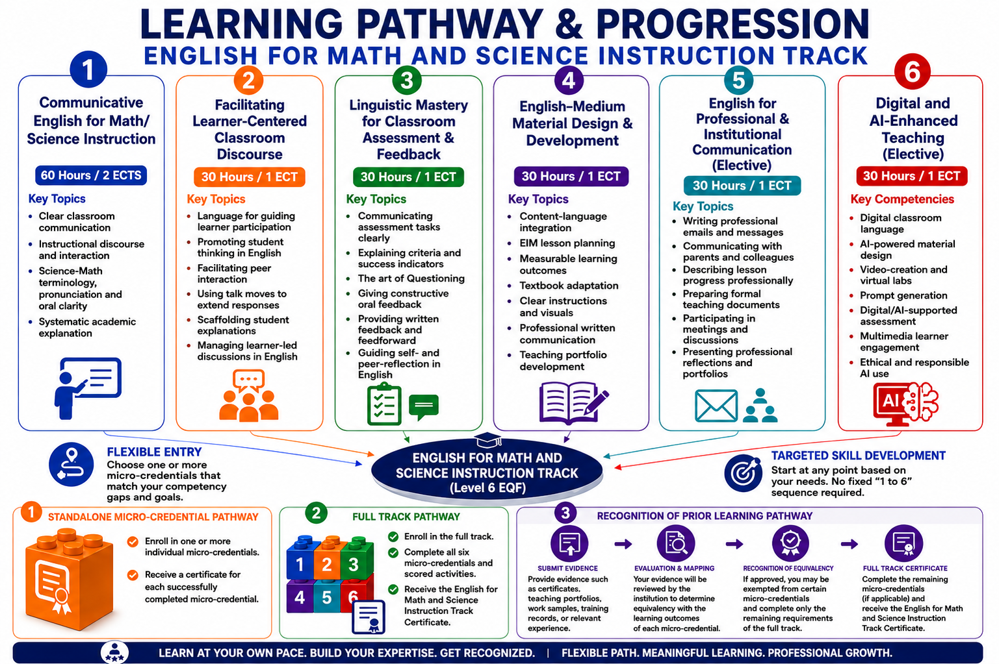
The track allows recognition of prior learning, certification, or relevant professional experience related to one or more micro-credentials. Applicants may submit evidence such as certificates, transcripts, portfolios, work samples, teaching records, or assessment evidence for institutional review. If equivalency is approved, learners may be exempted from the relevant micro-credential(s) and complete only the remaining requirements for the full track certificate. All decisions are subject to formal approval by the responsible academic body and depend on alignment with the relevant learning outcomes, workload, level, and assessment requirements.

12. Assessment and Certification
Each micro-credential includes its own assessment strategy aligned with the intended learning outcomes. Successful completion leads to the issuance of an individual micro-credential certificate. Completion of all required micro-credentials within the track may lead to a complementary track completion certificate.

13. Principles for Design and Issuance (Annex II)

13.1 Transparency
The English for Math & Science Instruction Track is designed to be transparent, understandable, and comparable through:
- Using a standardized micro-credential description template for all courses within the track.
- Providing clear information on the purpose and structure of each micro-credential.
- Clarifying expected learning outcomes, workload, and assessment requirements before enrollment.
- Supporting learners, trainers, reviewers, employers, and institutional stakeholders in understanding each micro-credential.
- Ensuring that micro-credential information remains clear and accessible before enrollment and after completion.

13.2 Quality Assurance
The English for Math & Science Instruction track is governed by a robust Quality Assurance (QA) system that shifts from informal evaluation to a systematic, evidence-based, and externally verifiable process. In alignment with European Micro-credential standards and EQF Level 6 principles. Quality is ensured through:
- A documented and evidence-based quality assurance process.
- Alignment with labor market needs
- Clear track and micro-credential specifications.
- Alignment between ILOs, modules, activities, assessment methods, and workload.
- Review of trainer readiness, learning materials, digital tools, and AI-supported resources.
- Monitoring of delivery, attendance, participation, learner progress, and portfolio evidence.
- Transparent rubrics, assessment moderation, grading review, and appeals procedures.
- Learner feedback, stakeholder feedback, and partner feedback.
- Internal quality assurance by the Faculty of Education – Ain Shams University.
- External review by the Training and Development Center – Ain Shams University.
- Post-training follow-up, training transfer, impact assessment, and continuous improvement action plans.

13.3 Recognition
The Mastering English for Math & Science Instruction Track supports recognition by clearly documenting the learning outcomes, workload, level, assessment methods, grade achieved, quality assurance arrangements, and evidence of achievement for each micro credential.
The micro credentials may be recognized for professional development, employment, training progression, or institutional purposes, subject to the regulations of the receiving institution or competent authority. Recognition does not automatically lead to an academic degree unless formally approved by the relevant institutional or national authorities.

13.4 Portability
The micro-credentials within the English for Math & Science Instruction Track are designed to be portable by providing clear, verifiable, and shareable evidence of learner achievement. Each issued micro-credential should include:
- Learner identification
- Title of the micro-credential
- Issuing body
- Learning outcomes
- Workload
- Level
- Assessment method
- Grade achieved
- Date of issue
- Quality assurance reference

Portability is supported through:
- Secure digital formats or institutional records.
- Easy sharing of micro-credentials with relevant bodies.
- Verification by educational, training, and employment institutions.
- Recognition across different professional and learning contexts.
- Protection of authenticity and learner ownership.

13.5 Learner-Centered Design
The Mastering English for Math & Science Instruction Track is designed around the needs of its target learners, including graduates and prospective teachers who aim to teach Mathematics and Science in English-medium school contexts. The track focuses on practical competencies that support learners’:
- Professional readiness
- Employability
- Confidence in classroom communication
- Academic explanation skills
- Assessment communication
- Lesson delivery performance
Learners are actively involved in the quality assurance process through:
- Feedback surveys
- Reflection tasks
- Peer review
- Portfolio evidence
- Participation in evaluation activities
Learner feedback is analyzed and used to improve:
- Module content
- Delivery methods
- Assessment practices
- Learner support
- Future implementation of the track.

13.6 Accessibility
The English for Math and Science Instruction Track and its associated micro-credentials adhere to the principle of accessibility by ensuring:
- Clear admission and registration procedures.
- Transparent information on requirements, workload, assessment, and certification.
- Flexible entry to one or more micro-credentials according to learner needs and availability.
- Blended delivery combining face-to-face and online learning.
- Clear materials, task instructions, and assessment guidelines.
- Academic, technical, or instructional support, where appropriate.
- Fair participation and equal opportunity for eligible learners.

13.7 Authenticity
The English for Math and Science Instruction Track and its micro-credentials adhere to the Principle of Authenticity, ensuring that every issued credential represents a verified, evidence-based record of the learner’s actual instructional competence. Authenticity is ensured through the following:
- Authentic Assessment Design
- Identity Verification and Supervision
- Traceability and Institutional Validation:
- Evidence-Based Achievement
- Follow-up, Training Transfer, and Impact Assessment:
- Consistency with EQF Standards:

13.8 Flexibility
The English for Math and Science Instruction Track and its micro-credentials adhere to the Principle of Flexibility through:

- Flexible Entry: Enroll in one or more micro-credentials without a fixed sequence.
- Stackable Learning: Each micro-credential stands alone or contributes to the full certificate.
- Flexible Completion: Complete all at once or accumulate overtime.
- Blended Delivery: Combines face-to-face practice, online tasks, and portfolio work.

13.9 Inclusiveness
The English for Math and Science Instruction Track and its micro-credentials adhere to the Principle of Inclusiveness. The track operationalizes inclusiveness through the following:

- Diverse Learners: Supports graduates, in-service teachers, and experienced educators.
- Supportive Environment: Encourages practice, progress, and constructive feedback.
- Equitable Learning: Accommodates different backgrounds and learning styles.
- Accessible Participation: Uses blended learning, guided practice, peer learning, and portfolio tasks.

14. Learner Support Services
- Academic mentoring
- Career guidance
- Technical support
- Accessibility accommodations
- Feedback and complaints mechanisms

15. Quality Assurance and Monitoring
The English for Math and Science Instruction Track is governed by a documented and evidence-based quality assurance process. This process ensures that the track is relevant, coherently designed, effectively delivered, fairly assessed, properly documented, and continuously improved. Quality assurance applies to the track as a whole and to its individual micro-credentials, covering learning outcomes, workload, delivery mode, assessment methods, rubrics, learner support, portfolio evidence, and certification requirements. Quality assurance is implemented through the following complementary mechanisms:
- Needs analysis and annual relevance review.
- Review of track and micro-credential specifications.
- Mapping of ILOs, modules, activities, workload, and assessment methods.
- Review of trainer qualifications, orientation, and delivery performance.
- Review of learning materials, digital tools, and AI-supported resources.
- Monitoring of attendance, participation, learner progress, and portfolio evidence.
- Use of transparent rubrics, moderation, grading review, and appeals procedures.
- Mid-track and end-track learner feedback surveys.
- Stakeholder and partner feedback.
- Course/module review reports and cohort quality assurance reports.
- Internal quality assurance by the Faculty of Education – Ain Shams University.
- External review by the Training and Development Center – Ain Shams University.
- Post-training follow-up, training transfer, impact assessment.
- continuous improvement action plans

16. Micro – Credential Fees:
Micro-credential fees will be set in accordance with the applicable institutional policies and financial regulations. Fees may differ according to the selected micro-credential(s), delivery arrangements, training requirements, and partnership-related considerations, and will be officially announced before registration.

17. Approval and Signatures
Track Coordinator: Marwa Mohamed Samir
Institution Representative: Dr. Safaa Ahmed Shehata
Date: 15/05/2026

18. References
European Council Recommendation on a European approach to micro-credentials for lifelong learning and employability (2022).

