ASU-TDC
TRaining and development center, Ain Shams university
Trainee Handbook for Complementary Tracks and Micro-Credentials

Trainee Handbook for the Complementary Track

Global Educator Preparation

1. Introduction
This trainee handbook has been designed to guide you throughout your professional learning journey and to support your development as a confident, reflective, and globally oriented educator. The track responds to the growing demand for teachers who are able to teach effectively in English-medium and international school contexts, where strong pedagogical knowledge, clear instructional communication, intercultural awareness, digital competence, and assessment literacy are all essential for successful teaching and learning.
The Global Educator Preparation track aims to prepare prospective and practicing educators to work effectively within international school environments. It supports participants in understanding the nature of international education, engaging with different curriculum models, using English as a medium of instruction, managing diverse and multicultural classrooms, designing learner-centered lessons, applying contemporary assessment practices, and integrating digital and AI-supported tools responsibly into teaching.
The track is structured as a micro-credential pathway, allowing participants to develop their competencies progressively through a set of focused learning units. Each micro-credential addresses a specific area of professional practice, while the full track provides an integrated preparation experience leading toward the Advanced Certificate in Global Educator Preparation. This structure offers both flexibility and coherence, enabling participants to build recognized competencies step by step.
Learning within this track is practice-oriented and performance-based. Participants will engage in blended learning activities, guided practice, classroom simulations, micro-teaching tasks, portfolio development, reflective assignments, and applied projects. The emphasis is not only on acquiring knowledge, but also on demonstrating the ability to apply that knowledge in realistic teaching situations. Throughout the track, participants are encouraged to connect theory with practice, reflect on their professional growth, and gather evidence of their readiness to teach in international school contexts.
This handbook explains the aims, structure, learning approach, expectations, assessment procedures, and professional requirements of the track. It also provides guidance on participation, portfolio development, micro-teaching, quality expectations, and successful completion. Participants are encouraged to use this handbook as a reference document throughout the training period and to return to it whenever they need clarification about the track requirements or learning expectations.
By joining this track, you are taking an important step toward global teaching excellence and toward developing your professional identity as a reflective, inclusive, innovative, and internationally minded educator.

2. Complementary Track MA
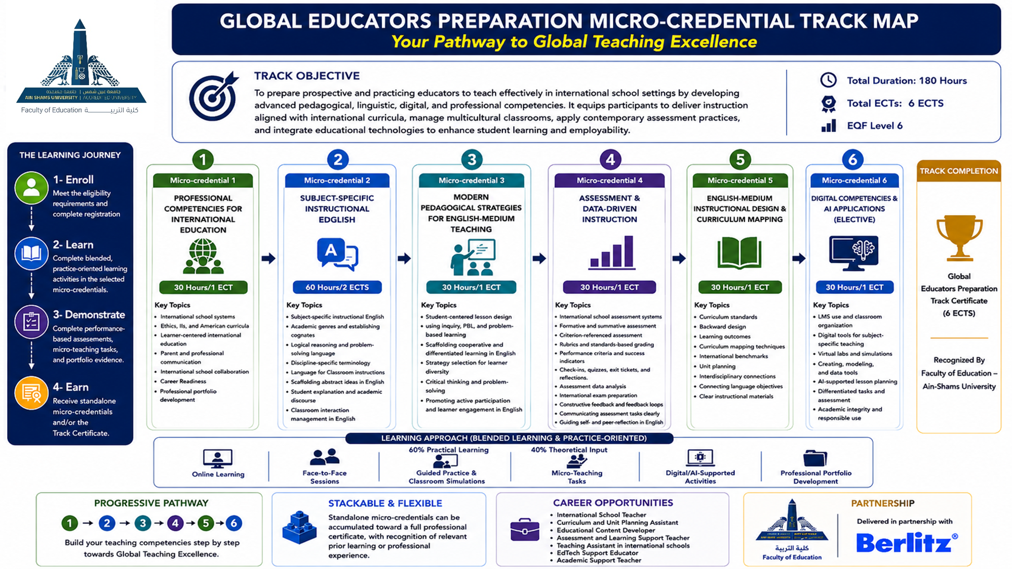

3. Registration Procedures
Applicants seeking to enroll in the Global Educator Preparation Track must complete the online registration through tdc.asu.edu.eg before the announced deadline. Applicants are required to submit all supporting documents requested by the Training and Development Center and the Faculty of Education – Ain Shams University.
Required documents include:
- Completed registration form.
- National ID card or passport copy
- Recent personal photo
- Academic qualification certificate or proof of enrollment
- Evidence of relevant academic background
- Proof of English language proficiency, where available
- Brief CV or professional profile
- Proof of teaching/professional experience, where applicable
- Payment receipt, where required
- Any additional documents requested by the TDC or Faculty of Education – Ain Shams University.
Registration is considered complete only after the online application has been submitted, the required documents have been received, and the applicant’s eligibility has been reviewed. Successful applicants will be notified of their enrollment status, selected micro-credential(s), training schedule, and any further administrative or payment procedures, where applicable.

4. Eligibility Criteria

Applicants should meet the following requirements:
- A relevant academic background in Education
- Prior teaching, training, classroom, tutoring, or instructional experience is preferred.
- English proficiency at B2 CEFR or above, with C1 preferred,
- Basic digital literacy

5. Prerequisites
There are no mandatory prerequisites for enrollment in the micro-credentials. Applicants may register for one or more micro-credentials according to their needs and professional gaps, without following a fixed sequence.

6. Transfer Between Complementary Tracks
To support flexibility and lifelong learning, learners may request transfer between complementary tracks based on completed micro-credentials, achieved ILOs, and equivalency with the target track. Transfer requests are reviewed case by case and may require evidence such as certificates, assessment results, or portfolio work. Final approval is subject to the track coordinator and/or the responsible academic body.

7. Complementary Track Overview
Track Name | Target Group | Duration | Total ECTS/Hours | Track Coordinator
Global Educator Preparation | - Graduates of Faculties of Education seeking opportunities in international or language schools.  - Prospective and practicing teachers aiming to teach through English.  - Teaching assistants and classroom support staff aspiring to work in international schools.  - Educational content developers, curriculum assistants, and academic support staff.  - Public or private school teachers seeking transition to international school contexts. | 180 training hours | 6 ECTS | Marwa Mohamed Samir

8. Learning Settings and Delivery Modes
The Global Educator Preparation Track adopts a practice-oriented, performance-based approach through blended learning, combining:
- online learning
- face-to-face sessions
- guided practice and classroom simulations,
- micro-teaching tasks,
- digital/AI-supported activities
- professional portfolio development.

.

9. Micro-Credentials Included in the Track
Micro-Credential Title | Learning Outcomes | ECTS/Hours | Assessment Method | Delivery Mode | EQF Level | Responsible Trainer
Professional Competencies for International Education | - Explain the philosophy, structures, and frameworks of international schools.  - Compare major international curricula, including British, IB, and American systems.  - Identify key features of international education, learner-centered learning, assessment, and standards.  - Demonstrate intercultural awareness and inclusive practices in diverse school contexts.  - Communicate professionally with parents, colleagues, and school communities.  - Prepare professional reports, documentation, and portfolio evidence.  - Collaborate effectively within international school communities.  - Prepare for international school recruitment, including demo lessons and competency-based interviews. | 1 ECTS | - Analytical Report  - Comparative Curriculum Analysis  - Case-Based Assessment  - Professional Portfolio Assessment  - Competency-Based Interview  - Peer and Trainer Evaluation | Face-to-face learning | 6
Subject-Specific Instructional English | - Use subject-specific instructional English to teach concepts clearly and accurately.  - Explain complex ideas, processes, and relationships using discipline-appropriate language.  - Model logical reasoning and guide problem-solving in English.  - Use accurate terminology related to the participant’s teaching discipline.  - Give precise classroom instructions and check learner understanding.  - Scaffold abstract ideas using examples, rephrasing, questioning, and visual support.  - Elicit student explanations and support academic discussion in English.  - Manage purposeful classroom interaction using clear and professional English.  - Use English strategically to enhance student understanding, engagement, and participation. | 2 ECTS | - Oral Performance Assessment  - Microteaching Assessment  - Observation Checklist  - Peer Review  - Self-Reflective Assessment | Blended learning | 6
Modern Pedagogical Strategies for English-Medium Teaching | - Apply student-centered pedagogical approaches in English-medium classrooms.  - Design engaging lessons that promote participation, understanding, and independent learning.  - Use inquiry-based, project-based, problem-based, and discovery learning strategies.  - Apply cooperative learning and differentiated instruction to support diverse learners.  - Use the 5E instructional model to structure active learning experiences.  - Select teaching strategies according to lesson objectives, learner needs, and subject content.  - Promote critical thinking, collaboration, reasoning, and problem-solving.  - Facilitate active student participation and learner engagement using clear classroom English.  - Create dynamic English-medium learning environments that support curiosity, interaction, and meaningful engagement. | 1 ECTS | - Oral Performance Assessment.  - Subject-Specific Vocabulary and Terminology Test  - Microteaching  - Observation  - Portfolio-Based Assessment  - Peer Assessment  - Self-Reflective Assessment | Blended learning | 6
Assessment & Data-Driven Instruction | - Analyze assessment systems used in international education.  - Design formative and summative assessments aligned with standards and learning outcomes.  - Apply criterion-related assessment approaches  - Develop rubrics, performance criteria, and standards-based grading tools.  - Use quizzes, exit tickets, check-ins, and performance tasks to monitor learning.  - Analyze assessment data to identify learning gaps and misconceptions.  - Adapt instruction based on assessment evidence.  - Provide specific, constructive feedback to support student improvement.  - Support student readiness for international examinations  - communicate assessment tasks, criteria, and expectations clearly in English.  - Provide specific, constructive feedback and use feedback loops to support continuous student improvement.  - Guide students in self-reflection and peer-reflection using appropriate academic English. | 1 ECTS | - Assessment Design Portfolio  - Formative and Summative Assessment Task  - Rubric and Performance Criteria Development  - Standards-Based Grading Task  - Assessment Data Analysis Report  - Case-Based Assessment Decision-Making  - Feedback Quality Assessment  - Instructional Adaptation Plan  - International Exam Preparation Task  - Peer Assessment  - Self-Reflective Assessment | Blended learning | 6
Instructional Design & Curriculum Mapping | - Interpret curriculum standards and expectations in international school contexts.  - Apply Backward Design to plan outcomes, assessments, lessons, and activities.  - Develop coherent unit plans aligned with learning outcomes and assessment criteria.  - Use curriculum mapping techniques to sequence learning across the school year.  - Map curriculum requirements against relevant international frameworks, standards, and benchmarks.  - Design interdisciplinary links between disciplines.  - Integrate content and language objectives in English-medium instructional planning.  - Plan differentiated learning experiences for diverse learners.  - Prepare clear, classroom-ready instructional plans, materials, and documentation. | 1 ECTS | - Curriculum Mapping Assessment  - Backward Design Unit Plan Assessment  - Lesson Planning Portfolio  - Curriculum Standards Interpretation Task  - Unit Plan and Assessment Alignment Review  - Interdisciplinary Planning Task  - Differentiated Instruction Design Assessment  - Instructional Documentation Assessment  - Case-Based Curriculum Planning Assessment  - Peer Assessment  - Self-Reflective Assessment | Blended learning | 6
Digital Competencies & AI Applications  (Elective) | - Use LMS tools for resource sharing, communication, assignment management, and assessment.  - Select appropriate digital tools to support teaching.  - Integrate virtual labs, simulations, graphing, modeling, and data tools into learning activities.  - Apply AI tools to support lesson planning, differentiated tasks, formative assessment, and material development.  - Design technology-enhanced activities that promote engagement and conceptual understanding.  - Evaluate digital and AI tools according to learning objectives, learner needs, and classroom context.  - Demonstrate responsible use of technology and AI, including academic integrity and data privacy. | 1 ECTS | - Digital Portfolio Assessment  - Practical Demonstration Assessment  - Technology-Enhanced Lesson Plan Assessment  - Digital Tool Selection and Justification Report  - AI-Supported Instructional Design Assessment  - Peer Assessment  - Self-Reflective Assessment | online learning | 6

10.Standard Elements for Each Micro-Credential (Annex I)

Title of the micro-credential | Professional Competencies for International Education
Learner Identification/Target Group | - Graduates of Faculties of Education seeking opportunities in international or language schools.  - Prospective and practicing teachers aiming to teach through English.  - Teaching assistants and classroom support staff aspiring to work in international schools.  - Educational content developers, curriculum assistants, and academic support staff.  - Public or private school teachers seeking transition to international school contexts.
Issuing Institution | Ain-Shams University
Date of issuing
Academic workload | The micro credential requires a total notional workload of 30 hours, equivalent to 1 ECTS credit. This workload includes contact hours, guided practice, independent preparation, performance-based tasks, feedback activities, and portfolio evidence required to achieve the intended learning outcomes.
participation Mode | Trainees participate in guided classroom language practice, role-play, pair work, classroom simulations, exit-ticket design, peer feedback, and short oral tasks using classroom situations
Quality assurance Process | The micro-credential is underpinned by an outcomes-based and performance-based quality assurance approach. Quality is ensured through clearly defined intended learning outcomes, module-level specifications, transparent assessment criteria, practical performance tasks, micro-teaching, portfolio evidence, trainer feedback, peer review, and learner self-reflection. The quality assurance process also includes internal review, stakeholder feedback, and continuous improvement mechanisms to ensure alignment with labor-market needs and the requirements of English-medium instruction in international school contexts.
Title of the micro-credential | Subject-Specific Instructional English
Learner Identification/Target Group | - Pre-service teachers in Faculties of Education.  - Graduates of Faculties of Education seeking employment in public, private schools.  - Teachers currently working in public schools aiming to enhance their English-medium teaching skills or transition to private and English-medium school contexts.  - Academic professionals seeking to enhance instructional delivery in English
Issuing Institution | Ain-Shams University
Date of issuing
Academic workload | The micro credential requires a total notional workload of 60 hours, equivalent to 2 ECTS credit. This workload includes contact hours, guided practice, independent preparation, performance-based tasks, feedback activities, and portfolio evidence required to achieve the intended learning outcomes.
participation Mode | Trainees participate in pronunciation drills, oral reading tasks, recorded speaking practice, shadowing exercises, peer listening, oral presentations, and trainer-guided feedback on pronunciation, pacing, intonation, and audibility.
Quality assurance Process | The micro-credential is underpinned by an outcomes-based and performance-based quality assurance approach. Quality is ensured through clearly defined intended learning outcomes, module-level specifications, transparent assessment criteria, practical performance tasks, micro-teaching, portfolio evidence, trainer feedback, peer review, and learner self-reflection. The quality assurance process also includes internal review, stakeholder feedback, and continuous improvement mechanisms to ensure alignment with labor-market needs and the requirements of English-medium instruction in international language school contexts.
Title of the micro-credential | Modern Pedagogical Strategies for English-Medium Teaching
Learner Identification/Target Group | - Graduates of Faculties of Education seeking opportunities in international or language schools.  - Prospective and practicing teachers aiming to teach through English.  - Teaching assistants and classroom support staff aspiring to work in international schools.  - Educational content developers, curriculum assistants, and academic support staff.  - Public or private school teachers seeking transition to international school contexts.
Issuing Institution | Ain-Shams University
Date of issuing
Academic workload | The micro credential requires a total notional workload of 30 hours, equivalent to 1 ECTS credit. This workload includes contact hours, guided practice, independent preparation, performance-based tasks, feedback activities, and portfolio evidence required to achieve the intended learning outcomes.
participation Mode | Trainees participate in guided explanation practice, data commentary tasks, mini-presentations, peer discussion, explanation-script development, visual interpretation activities, and feedback-based revision.
Quality assurance Process | The micro-credential is underpinned by an outcomes-based and performance-based quality assurance approach. Quality is ensured through clearly defined intended learning outcomes, module-level specifications, transparent assessment criteria, practical performance tasks, micro-teaching, portfolio evidence, trainer feedback, peer review, and learner self-reflection. The quality assurance process also includes internal review, stakeholder feedback, and continuous improvement mechanisms to ensure alignment with labor-market needs and the requirements of English-medium instruction in international school contexts.
Title of the micro-credential | Assessment & Data-Driven Instruction
Learner Identification/Target Group | - Graduates of Faculties of Education seeking opportunities in international or language schools.  - Prospective and practicing teachers aiming to teach through English.  - Teaching assistants and classroom support staff aspiring to work in international schools.  - Educational content developers, curriculum assistants, and academic support staff.  - Public or private school teachers seeking transition to international school contexts.
Issuing Institution | Ain-Shams University
Date of issuing
Academic workload | The micro credential requires a total notional workload of 30 hours, equivalent to 1 ECTS credit. This workload includes contact hours, guided practice, independent preparation, performance-based tasks, feedback activities, and portfolio evidence required to achieve the intended learning outcomes.
participation Mode | Trainees participate in assessment-language practice, rubric interpretation, feedback and feedforward tasks, questioning practice, peer review, self-reflection activities, and classroom-based assessment simulations.
Quality assurance Process | The micro-credential is underpinned by an outcomes-based and performance-based quality assurance approach. Quality is ensured through clearly defined intended learning outcomes, module-level specifications, transparent assessment criteria, practical performance tasks, micro-teaching, portfolio evidence, trainer feedback, peer review, and learner self-reflection. The quality assurance process also includes internal review, stakeholder feedback, and continuous improvement mechanisms to ensure alignment with labor-market needs and the requirements of English-medium instruction in international school contexts.
Title of the micro-credential | English-Medium Instructional Design & Curriculum Mapping
Learner Identification/Target Group | - Graduates of Faculties of Education seeking opportunities in international or language schools.  - Prospective and practicing teachers aiming to teach through English.  - Teaching assistants and classroom support staff aspiring to work in international schools.  - Educational content developers, curriculum assistants, and academic support staff.  - Public or private school teachers seeking transition to international school contexts.
Issuing Institution | Ain-Shams University
Date of issuing
Academic workload | The micro credential requires a total notional workload of 30 hours, equivalent to 1 ECTS credit. This workload includes contact hours, guided practice, independent preparation, performance-based tasks, feedback activities, and portfolio evidence required to achieve the intended learning outcomes.
participation Mode | Trainees participate in hands-on digital tool exploration, AI prompt-writing practice, multimedia design tasks, simulation-based activities, digital assessment tasks, content verification activities, and collaborative production of digital resources.
Quality assurance Process | The micro-credential is underpinned by an outcomes-based and performance-based quality assurance approach. Quality is ensured through clearly defined intended learning outcomes, module-level specifications, transparent assessment criteria, practical performance tasks, micro-teaching, portfolio evidence, trainer feedback, peer review, and learner self-reflection. The quality assurance process also includes internal review, stakeholder feedback, and continuous improvement mechanisms to ensure alignment with labor-market needs and the requirements of English-medium instruction in international school contexts.
Title of the micro-credential | Digital Competencies & AI Applications (Elective)
Learner Identification/Target Group | - Graduates of Faculties of Education seeking opportunities in international or language schools.  - Prospective and practicing teachers aiming to teach through English.  - Teaching assistants and classroom support staff aspiring to work in international schools.  - Educational content developers, curriculum assistants, and academic support staff.  - Public or private school teachers seeking transition to international school contexts.
Issuing Institution | Ain-Shams University
Date of issuing
Academic workload | The micro credential requires a total notional workload of 30 hours, equivalent to 1 ECTS credit. This workload includes contact hours, guided practice, independent preparation, performance-based tasks, feedback activities, and portfolio evidence required to achieve the intended learning outcomes.
participation Mode | Trainees participate in collaborative learning tasks, learner-centered activity design, simulations of group work, inquiry and problem-solving tasks, classroom dialogue practice, peer facilitation, and reflective discussion.
Quality assurance Process | The micro-credential is underpinned by an outcomes-based and performance-based quality assurance approach. Quality is ensured through clearly defined intended learning outcomes, module-level specifications, transparent assessment criteria, practical performance tasks, micro-teaching, portfolio evidence, trainer feedback, peer review, and learner self-reflection. The quality assurance process also includes internal review, stakeholder feedback, and continuous improvement mechanisms to ensure alignment with labor-market needs and the requirements of English-medium instruction in international school contexts.

11. Learning Pathway and Progression
The Global Educator Preparation Track is designed as a flexible and stackable learning pathway. It allows three possible pathways:
- Standalone Micro-Credential Pathway
Participants may enroll in one or more individual micro-credentials and receive a certificate for each successfully completed micro-credential.
- Full Track Pathway
Learners may enroll in the full track and receive the Global Educator Preparation Track Certificate upon completing all seven micro-credentials, required assessments, and portfolio evidence.
- Recognition of Prior Learning Pathway
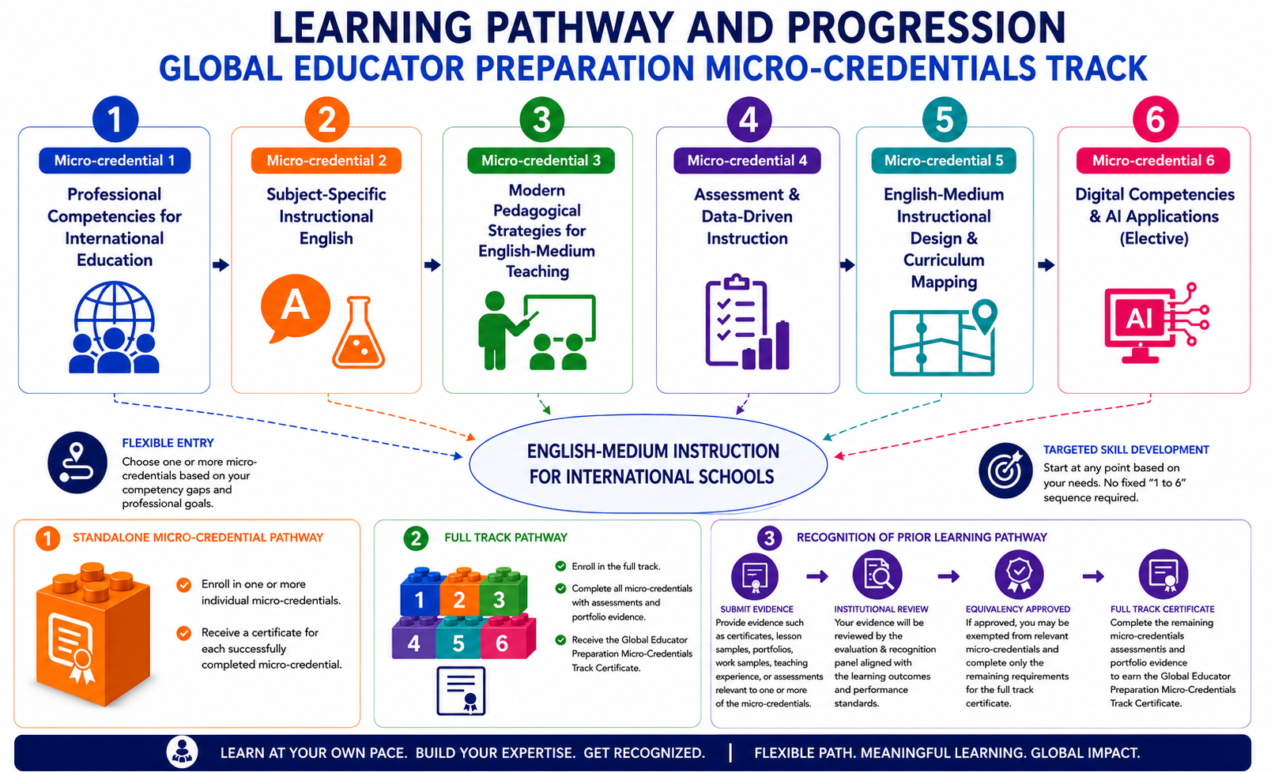
The track allows recognition of prior learning, certification, or relevant professional experience related to one or more micro-credentials. Applicants may submit evidence such as certificates, transcripts, portfolios, work samples, teaching records, or assessment evidence for institutional review. If equivalency is approved, learners may be exempted from the relevant micro-credential(s) and complete only the remaining requirements for the full track certificate. All decisions are subject to formal approval by the responsible academic body and depend on alignment with the relevant learning outcomes, workload, level, and assessment requirements.

12. Assessment and Certification
Each micro-credential includes its own assessment strategy aligned with the intended learning outcomes. Successful completion leads to the issuance of an individual micro-credential certificate. Completion of all required micro-credentials within the track may lead to a complementary track completion certificate.

13. Principles for Design and Issuance (Annex II)

13.1 Transparency
The Global Educator Preparation Track is designed to be transparent, understandable, and comparable through:
- Using a standardized micro-credential description template for all courses within the track.
- Providing clear information on the purpose and structure of each micro-credential.
- Clarifying expected learning outcomes, workload, and assessment requirements before enrollment.
- Supporting learners, trainers, reviewers, employers, and institutional stakeholders in understanding each micro-credential.
- Ensuring that micro-credential information remains clear and accessible before enrollment and after completion.

13.2 Quality Assurance
The Global Educator Preparation track is governed by a robust Quality Assurance (QA) system that shifts from informal evaluation to a systematic, evidence-based, and externally verifiable process. In alignment with European Micro-credential standards and EQF Level 6 principles. Quality is ensured through:
- A documented and evidence-based quality assurance process.
- Alignment with labor market needs
- Clear track and micro-credential specifications.
- Alignment between ILOs, modules, activities, assessment methods, and workload.
- Review of trainer readiness, learning materials, digital tools, and AI-supported resources.
- Monitoring of delivery, attendance, participation, learner progress, and portfolio evidence.
- Transparent rubrics, assessment moderation, grading review, and appeals procedures.
- Learner feedback, stakeholder feedback, and partner feedback.
- Internal quality assurance by the Faculty of Education – Ain Shams University.
- External review by the Training and Development Center – Ain Shams University.
- Post-training follow-up, training transfer, impact assessment, and continuous improvement action plans.

13.3 Recognition
The Global Educator Preparation Track supports recognition by clearly documenting the learning outcomes, workload, level, assessment methods, grade achieved, quality assurance arrangements, and evidence of achievement for each micro credential.
The micro credentials may be recognized for professional development, employment, training progression, or institutional purposes, subject to the regulations of the receiving institution or competent authority. Recognition does not automatically lead to an academic degree unless formally approved by the relevant institutional or national authorities.

13.4 Portability
The micro-credentials within the Global Educator Preparation Track are designed to be portable by providing clear, verifiable, and shareable evidence of learner achievement. Each issued micro-credential should include:
- Learner identification
- Title of the micro-credential
- Issuing body
- Learning outcomes
- Workload
- Level
- Assessment method
- Grade achieved
- Date of issue
- Quality assurance reference

Portability is supported through:
- Secure digital formats or institutional records.
- Easy sharing of micro-credentials with relevant bodies.
- Verification by educational, training, and employment institutions.
- Recognition across different professional and learning contexts.
- Protection of authenticity and learner ownership.

13.5 Learner-Centered Design

The Global Educator Preparation track is designed around the needs of its target learners, including graduates, prospective teachers, practicing teachers, teaching assistants, and education professionals who aim to teach or support learning in international school contexts. The track focuses on practical competencies that support learners’:
- Professional readiness
- Employability
- Confidence in classroom communication
- Academic explanation skills
- Assessment communication
- Lesson delivery performance
Learners are actively involved in the quality assurance process through:
- Feedback surveys
- Reflection tasks
- Peer review
- Portfolio evidence
- Participation in evaluation activities
Learner feedback is analyzed and used to improve:
- Module content
- Delivery methods
- Assessment practices
- Learner support
- Future implementation of the track.

13.6 Accessibility
The Global Educator Preparation Track and its associated micro-credentials adhere to the principle of accessibility by ensuring:
- Clear admission and registration procedures.
- Transparent information on requirements, workload, assessment, and certification.
- Flexible entry to one or more micro-credentials according to learner needs and availability.
- Blended delivery combining face-to-face and online learning.
- Clear materials, task instructions, and assessment guidelines.
- Academic, technical, or instructional support, where appropriate.
- Fair participation and equal opportunity for eligible learners.

13.7 Authenticity
The Global Educator Preparation Track and its micro-credentials adhere to the Principle of Authenticity, ensuring that every issued credential represents a verified, evidence-based record of the learner’s actual instructional competence. Authenticity is ensured through the following:
- Authentic Assessment Design
- Identity Verification and Supervision
- Traceability and Institutional Validation:
- Evidence-Based Achievement
- Follow-up, Training Transfer, and Impact Assessment:
- Consistency with EQF Standards:

13.8 Flexibility
The Global Educator Preparation Track and its micro-credentials adhere to the Principle of Flexibility through:

- Flexible Entry: Enroll in one or more micro-credentials without a fixed sequence.
- Stackable Learning: Each micro-credential stands alone or contributes to the full certificate.
- Flexible Completion: Complete all at once or accumulate overtime.
- Blended Delivery: Combines face-to-face practice, online tasks, and portfolio work.

13.9 Inclusiveness
The Global Educator Preparation Track and its micro-credentials adhere to the Principle of Inclusiveness. The track operationalizes inclusiveness through the following:

- Diverse Learners: Supports graduates, in-service teachers, and experienced educators.
- Supportive Environment: Encourages practice, progress, and constructive feedback.
- Equitable Learning: Accommodates different backgrounds and learning styles.
- Accessible Participation: Uses blended learning, guided practice, peer learning, and portfolio tasks.

14. Learner Support Services
- Academic mentoring
- Career guidance
- Technical support
- Accessibility accommodations
- Feedback and complaints mechanisms

15. Quality Assurance and Monitoring
The Global Educator Preparation Track is governed by a documented and evidence-based quality assurance process. This process ensures that the track is relevant, coherently designed, effectively delivered, fairly assessed, properly documented, and continuously improved. Quality assurance applies to the track as a whole and to its individual micro-credentials, covering learning outcomes, workload, delivery mode, assessment methods, rubrics, learner support, portfolio evidence, and certification requirements. Quality assurance is implemented through the following complementary mechanisms:
- Needs analysis and annual relevance review.
- Review of track and micro-credential specifications.
- Mapping of ILOs, modules, activities, workload, and assessment methods.
- Review of trainer qualifications, orientation, and delivery performance.
- Review of learning materials, digital tools, and AI-supported resources.
- Monitoring of attendance, participation, learner progress, and portfolio evidence.
- Use of transparent rubrics, moderation, grading review, and appeals procedures.
- Mid-track and end-track learner feedback surveys.
- Stakeholder and partner feedback.
- Course/module review reports and cohort quality assurance reports.
- Internal quality assurance by the Faculty of Education – Ain Shams University.
- External review by the Training and Development Center – Ain Shams University.
- Post-training follow-up, training transfer, impact assessment.
- continuous improvement action plans

16. Micro – Credential Fees:
Micro-credential fees will be set in accordance with the applicable institutional policies and financial regulations. Fees may differ according to the selected micro-credential(s), delivery arrangements, training requirements, and partnership-related considerations, and will be officially announced before registration.

17. Approval and Signatures
Track Coordinator: Marwa Mohamed Samir
Institution Representative: Dr. Safaa Ahmed Shehata
Date: 15/05/2026

18. References
European Council Recommendation on a European approach to micro-credentials for lifelong learning and employability (2022).

