ASU-TDC
TRaining and development center, Ain Shams university
Trainee Handbook for Complementary Tracks and Micro-Credentials

Trainee Handbook for Complementary Tracks and Micro-Credentials
Digital Media Content Creation Track
Faculty of Mass Communication – Ain Shams University

This handbook template is designed for complementary learning tracks that include multiple European micro-credentials. It follows the European Council Recommendation on a European approach to micro-credentials for lifelong learning and employability, particularly Annex I (Standard Elements) and Annex II (Principles for Design and Issuance).

1. Introduction
The handbook provides trainees with guidance regarding complementary tracks, included micro-credentials, registration procedures, eligibility criteria, learning pathways, assessment methods, learner support services, quality assurance mechanisms, and certification procedures.
The Digital Media Content Creation Track is a complementary professional learning track designed according to the European Micro-Credentials framework to provide learners with integrated competencies in digital media production and media convergence.
The track combines theoretical foundations with intensive practical training in multimedia storytelling, digital publishing, visual communication, podcast production, and short-form video creation.
The program aims to bridge the gap between academic education and labor market requirements while supporting innovation, employability, entrepreneurship, digita transformation and freelancing opportunities within the digital media ecosystem.

2. Complementary Track MAP

Learning Journey
Digital Media Content Creation Track
⬇
Module 1: Creative Media Content Writing
- Digital Writing
- Storytelling
- Script Writing
- SEO Content
⬇
Module 2: Short Video Production
- Mobile Filming
- Directing
- Editing
- Reels & Shorts Production
⬇
Module 3: Podcast Production
- Podcast Planning
- Audio Recording
- Voice Presentation
- Digital Publishing
⬇
Module 4: Graphic & Visual Design
- Social Media Design
- Branding
- Visual Communication
- Infographics
⬇
Final Integrated Project
- Written Content
- Short Video
- Podcast Episode
- Visual Designs
- Digital Publishing Plan

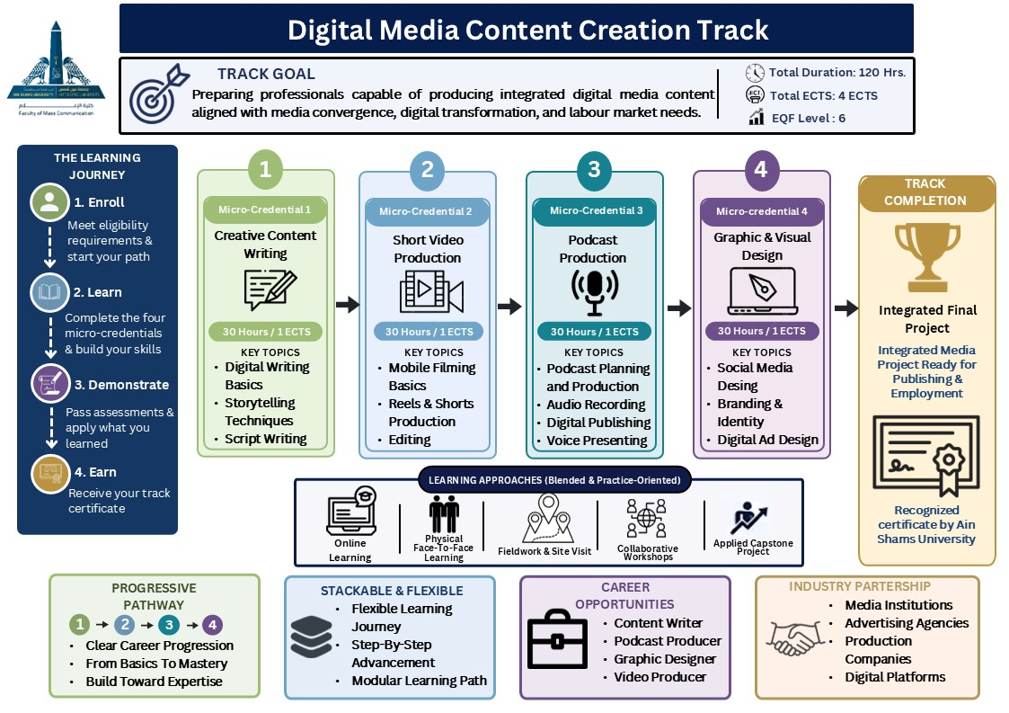
Figure (1) Digital media content creation track guide

3. Registration Procedures
Applicants must complete the online registration through tdc.asu.edu.eg and submit all required supporting documents before the announced deadlines.
- Completed registration form.
- Approval of prerequisites where required (Appendix 1).

4. Eligibility Criteria
Eligibility requirements may vary according to the complementary track and associated micro-credentials. Applicants should meet the minimum academic and/or professional criteria.
- Minimum educational qualification:
- Undergraduate university students (preferably from second year and above).
OR
- Holders of a university degree or accredited professional diploma.
- Relevant professional background:
- Preferred Academic or Professional Background:
Applicants are preferably expected to have prior background in:
- Media Studies
- Marketing
- Public Relations
- Communication
- Journalism
- Radio & Television
- Digital Arts
- Multimedia Design
- Digital Literacy Requirements:
- Ability to use basic computer applications.
- Familiarity with social media platforms.
- Ability to use email and online learning platforms.

5. Prerequisites
The track adopts an integrated sequential learning model where competencies are progressively developed across modules.
General Prerequisites:
- Introductory study in digital media.
- Basic knowledge of digital marketing.
- Fundamentals of media writing.
- Introductory knowledge of photography and video production.
- Basic familiarity with social media platforms.
Module Prerequisites
Module | Prerequisite
Creative Media Content Writing | None
Short Video Production | Successful completion of Module 1 or equivalent
Podcast Production | Successful completion of Modules 1 & 2 or equivalent
Graphic & Visual Design | Successful completion of Modules 1, 2 & 3 or equivalent
Flexible Entry Policy:
Learners with relevant academic or professional backgrounds may directly enroll in selected modules after passing a placement assessment.

6. Transfer Between Complementary Tracks
Transfer between complementary tracks is allowed according to:
- Learning outcomes equivalency.
- Academic content equivalency.
- Approval of the academic committee.
- Fulfillment of prerequisite requirements.
Transfer requests are subject to approval by the academic coordinator.

7. Complementary Track Overview
Track Name | Target Group | Duration | Total ECTS/Hours | Track Coordinator
Digital Media Content Creation Track | Media students and graduates, digital content creators, freelancers, PR professionals | 120 Training Hours | 4 ECTS / 120 Hours | Faculty of Mass Communication – Ain Shams University

8. Learning Settings and Delivery Modes
The complementary track follows a practice-oriented approach where practical learning constitutes a minimum of 60% of the learning activities, while theoretical learning constitutes a maximum of 40%.
Official Delivery Mode:
- Blended Learning
Learning Settings Distribution:
Learning Setting | Percentage | Hours
Online Learning | 40% | 48 Hours
Face-to-Face Workshops | 30% | 36 Hours
Studio & Lab Training | 20% | 24 Hours
Final Project Supervision | 10% | 12 Hours

9. Micro-Credentials Included in the Track
Micro-Credential Title | Learning Outcomes | ECTS/Hours | Assessment Method | Delivery Mode | EQF Level | Responsible Trainer
Creative Media Content Writing. | - Produce professional digital written content.  - Apply digital storytelling techniques.  - Write scripts for digital platforms.  - Optimize content for SEO.  - Analyze target audiences. | 1 ECTS / 30 Hours | - Written assignments.  - Applied project. | Blended | Level 6 | Media Content Specialist
Short Video Production | - Produce professional short-form videos.  - Apply directing and visual composition principles.  - Use basic editing software.  - Produce Reels & Shorts content.  - Utilize lighting and sound appropriately | 1 ECTS / 30 Hours | - Practical production.  - Video project.  - Applied evaluation | Blended | Level 6 | Video Production Specialist
Podcast Production | - Plan podcast episodes professionally.  - Record high-quality audio.  - Apply voice presentation techniques.  - Edit audio and sound effects.  - Publish and distribute podcast episodes digitally. | 1 ECTS / 30 Hours | - Audio project. | Blended | Level 6 | Podcast And Production Specialist
Graphic & Visual Design | - Create professional visual content.  - Design social media visuals.  - Apply branding and visual identity principles.  - Produce infographics and presentations.  - Use digital design tools effectively | 1 ECTS / 30 Hours | Design Portfolio | Blended | Level 6 | Graphic Design Specialist

10. Standard Elements for Each Micro-Credential (Annex I)

10.1 Learner identification
Each learner receives a unique identification number according to university regulations.

10.2 Title of the micro-credential
Each awarded certificate clearly identifies the micro-credential title.

10.3 Issuing institution
Faculty of Mass Communication – Ain Shams University.
Media Institutions & Professional Partnerships.
Proposed Partnerships:
- National media institutions.
- Television channels.
- Radio networks.
- Advertising and digital marketing agencies.
- Digital publishing platforms.
- Media production companies.
- Podcast production studios.
Suggested Examples:
- Akhbar Al-Youm
- Maspero

10.4 Date of issue
Each certificate includes the official issue date.

10.5 Learning outcomes
Learning outcomes align with EQF Level 6 and focus on practical digital media competencies.

10.6 Academic workload
Each micro-credential includes approximately 30 guided learning hours.

10.7 EQF level
All micro-credentials included are aligned with EQF Level 6.

10.8 Assessment type
Assessment methods include:
- Assignments
- Practical projects
- Participation
- Portfolio production
- Final project.

10.9 Participation mode
• the track is delivered through a Blended Learning model combining face-to-face and online learning activities.

10.10 Quality assurance process
The track follows institutional quality assurance procedures including:
- Continuous evaluation
- Curriculum review
- Learner feedback
- Trainer assessment
- Labor market alignment

11. Learning Pathway and Progression
The track follows a progressive learning pathway that enables trainees to acquire integrated multimedia production competencies.
Learning Sequence:
- Creative Media Content Writing
⬇
- Short Video Production
⬇
- Podcast Production
⬇
- Graphic & Visual Design
⬇
- Integrated Final Media Project
Learners may complete individual modules independently or complete the full track for broader specialization.
Suggested Training Timeline
The complementary track is delivered through a flexible blended learning model based on two training days per week.
Suggested Duration:
• Full Track Duration: Approximately 4 Months
• Each Micro-Credential Duration: Approximately 4 Weeks
• Training Schedule: 2 Days Per Week
The flexible scheduling model allows learners to balance academic, professional, and practical training requirements while ensuring continuous engagement throughout the track.

12. Assessment and Certification
Each micro-credential includes its own assessment strategy aligned with intended learning outcomes.
Assessment Distribution:
- Participation and activities (20%)
- Assignments and tasks (20%)
- Practical evaluation (30%)
- Final integrated project (30%)
Certification:
Successful learners receive:
- Individual Micro-Credential Certificates
- Complementary Track Completion Certificate

13. Principles for Design and Issuance (Annex II)

13.1 Transparency
The complementary track and its associated micro-credentials adhere to the principle of transparency.

13.2 Quality Assurance
The complementary track and its associated micro-credentials adhere to the principle of quality assurance.

13.3 Recognition
The complementary track and its associated micro-credentials adhere to the principle of recognition.

13.4 Portability
The complementary track and its associated micro-credentials adhere to the principle of portability.

13.5 Learner-Centred Design
The complementary track and its associated micro-credentials adhere to the principle of learner-centred design.

13.6 Accessibility
The complementary track and its associated micro-credentials adhere to the principle of accessibility.

13.7 Authenticity
The complementary track and its associated micro-credentials adhere to the principle of authenticity.

13.8 Flexibility
The complementary track and its associated micro-credentials adhere to the principle of flexibility.

13.9 Inclusiveness
The complementary track and its associated micro-credentials adhere to the principle of inclusiveness.

14. Learner Support Services
- Academic mentoring
- Career guidance
- Technical support
- Accessibility accommodations
- Mechanism of feedback and complaints

15. Quality Assurance and Monitoring
Regular monitoring and evaluation procedures are implemented to ensure the quality, relevance, and continuous improvement of all complementary tracks and micro-credentials.
Continuous monitoring procedures are implemented through:
- Curriculum review
- Learner satisfaction surveys
- Trainer performance evaluation
- Industry consultation
- Continuous improvement strategies

16. Micro – Credential Fees:
Fees are determined according to:
- University regulations
- Number of enrolled modules
- Training facilities and technological resources

17. Approval and Signatures
Track Coordinator: __________________________
Institution Representative: __________________
Date: ______________________________________

18. References
European Council Recommendation on a European approach to micro-credentials for lifelong learning and employability (2022).

